FOR SALE

MID TERRACED RETAIL UNIT

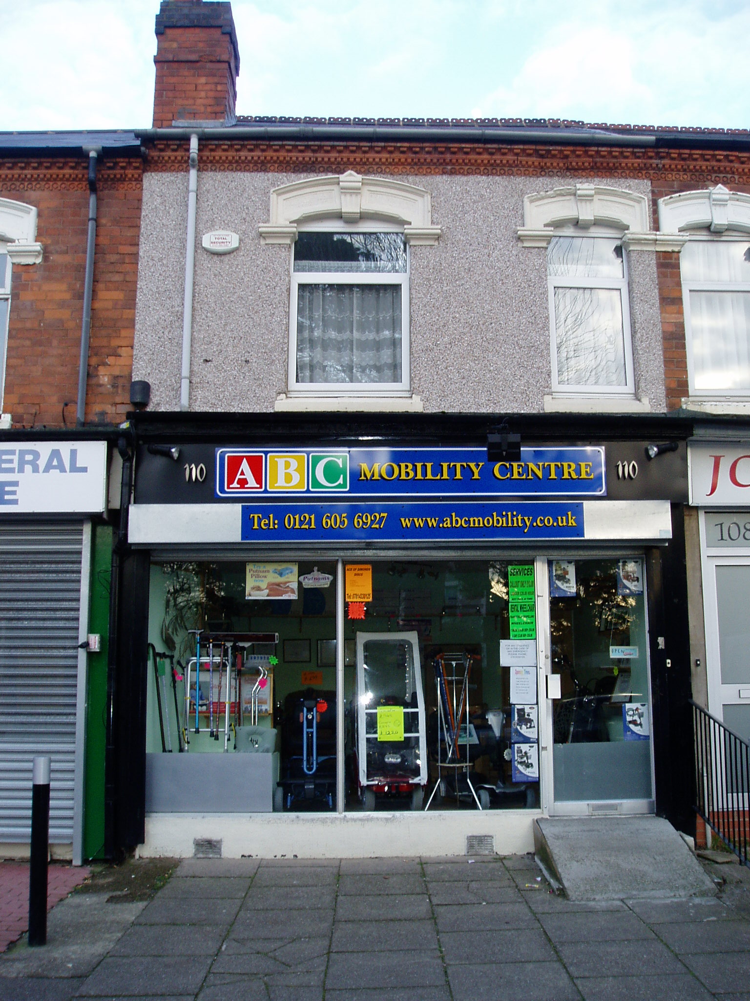

110 YARDLEY ROAD
ACOCKS GREEN
BIRMINGHAM
B27 6LG

- Freehold Interest

- Full Vacant Possession

- First Floor Flat

LOCATION

DESCRIPTION

ACCOMMODATION

ASKING PRICE

TENURE

RATING ASSESSMENT

PLANNING

VIEWING

The property is located in the middle of a parade of similar units on Yardley Road close to the junction with Cottesbrook Road.

The property is located in the predominantly residential suburb of Yardley, which is located approximately 3.5 miles to the South East of Birmingham City Centre.

A mid terraced Retail Unit, which has formerly been trading as a ‘ABC Mobility Centre’, offered for sale in a parade of retail units. The retail area itself benefits from Roller Shutter Protection, metal framed shop front, laminate flooring, suspended ceiling and central heating. In addition, there is a flat to the First Floor, which has been recently refurbished and benefits from upvc Double Glazing, modern kitchen and bathroom fittings and central heating.

Ground Floor
Front Retail Area 4.14m x 4.36m = 18sq.m. (194sq.ft.)
Rear Retail Area 3.42m x 3.73m = 12.7sq.m. (137sq.ft.)
Store Room 5.49m x 3.31m = 18.1sq.m. (195sq.ft.)
Rear Lobby with door to
Kitchen/Diner 2.64m x 4.94m max

First Floor
Stairs and Landing
Front Reception Room 4.29m x 3.45m
Bedroom 1 3.73m x 2.33m
Bedroom 2 2.69m x 2.77m
Bathroom with wash hand basin, WC, panelled bath with shower over and fully tiles walls 1.99m x 1.73m

We are seeking offers in the region of £165,000

The property is of a Freehold tenure, please make your own enquiries from the Land Registry to confirm this information

Rateable Value – SHOP AND PREMISES £1,675
Rates Payable – £743.70 per annum, approximately
Please make you own enquiries of Birmingham City Council, to confirm the accuracy of these figures

We have made no formal enquiries as to the current planning usage, however we have been advised by the Landlord that the property benefits from Full A1 Consent, and potential tenants are advised to contact Birmingham City Council Planning Department on 0121 303 1115.

By appointment with Cottons 0121 247 2233

